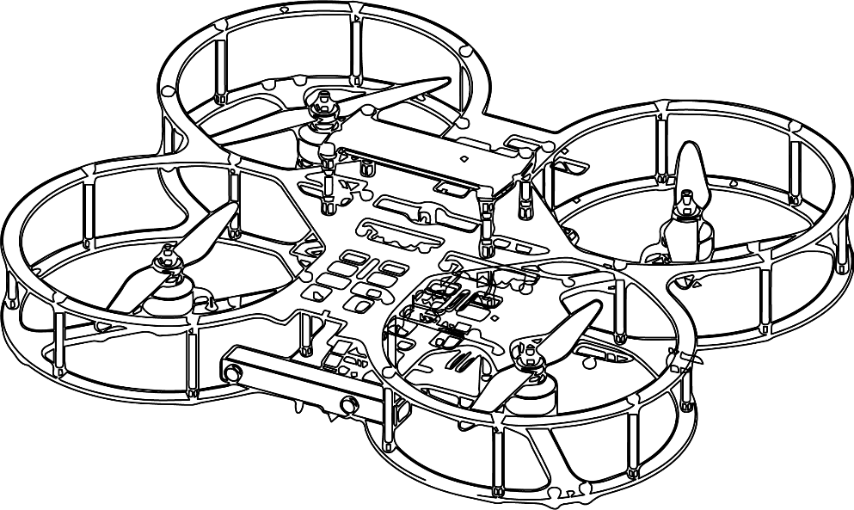

**Autonomous Vehicles Research Studio**

Setup Guide – QDrone 1 Hover Test

© 2023 Quanser Inc., All rights reserved

For more information on the solutions Quanser Inc. offers,   
please visit the web site at: <http://www.quanser.com>

|  |  |
| --- | --- |
| Quanser Inc.  119 Spy Court  Markham, Ontario  L3R 5H6, Canada | info@quanser.com  Phone : 19059403575  Fax : 19059403576  printed in Markham, Ontario. |

This document and the software described in it are provided subject to a license agreement. Neither the software nor this document may be used or copied except as specified under the terms of that license agreement. Quanser Inc. grants the following rights: a) The right to reproduce the work, to incorporate the work into one or more collections, and to reproduce the work as incorporated in the collections, b) to create and reproduce adaptations provided reasonable steps are taken to clearly identify the changes that were made to the original work, c) to distribute and publicly perform the work including as incorporated in collections, and d) to distribute and publicly perform adaptations. The above rights may be exercised in all media and formats whether now known or hereafter devised. These rights are granted subject to and limited by the following restrictions: a) You may not exercise any of the rights granted to You in above in any manner that is primarily intended for or directed toward commercial advantage or private monetary compensation, and b) You must keep intact all copyright notices for the Work and provide the name Quanser Inc. for attribution. These restrictions may not be waved without express prior written permission of Quanser Inc.

**FCC Notice** This device complies with Part 15 of the FCC rules. Operation is subject to the following two conditions: (1) this device may not cause harmful interference, and (2) this device must accept any interference received, including interference that may cause undesired operation.

**Industry Canada Notice** This Class A digital apparatus complies with Canadian ICES-003. Cet appareil numérique de la classe A est conforme à la norme NMB-003 du Canada.

**Waste Electrical and Electronic Equipment (WEEE)**

This symbol indicates that waste products must be disposed of separately from municipal household waste, according to Directive 2002/96/EC of the European Parliament and the Council on waste electrical and electronic equipment (WEEE). All products at the end of their life cycle must be sent to a WEEE collection and recycling center. Proper WEEE disposal reduces the environmental impact and the risk to human health due to potentially hazardous substances used in such equipment. Your cooperation in proper WEEE disposal will contribute to the effective usage of natural resources.

|  |  |
| --- | --- |
|  | This product meets the essential requirements of applicable European Directives as follows:   * 2006/95/EC; Low-Voltage Directive (safety) * 2004/108/EC; Electromagnetic Compatibility Directive (EMC)   **Warning**: This is a Class A product. In a domestic environment this product may cause radio interference, in which case the user may be required to take adequate measures. |
| caution.png **Caution** | **This equipment is designed to be used for educational and research purposes and is not intended for use by the public.** The user is responsible to ensure that the equipment will be used by technically qualified personnel only. While the end-effector board provides connections for external user devices, users are responsible for certifying any modifications or additions they make to the default configuration. |

Table of Contents

A. Before the Hover Test 3

B. QDrone 1 Hover Check 4

# Before the Hover Test

At this point, all the checkpoint tasks outlined in the table below should have been completed.

1. Your localization system should have been set up and functional.
2. You should be comfortable setting up and using the FrSky Taranis X9 Lite S Joystick
3. Your ground control station PC should be set up and functional.
4. The communication infrastructure between the ground control station PC, router and vehicles should be functional.

|  |
| --- |
| **Note:** Please contact the Quanser Engineer supporting you to start planning the commissioning and training process. |

|  |  |  |
| --- | --- | --- |
| Step | Done? | Section |
| 1/2 |  | Set up Workspace with Nets and Charge Vehicles |
| 3 |  | Mount OptiTrack Cameras |
| 4 |  | Ground PC Setup (Connecting All Components) |
| 5 |  | Software Licensing and Testing (Sine Scope Demo) |
| 6 |  | Joystick Testing and Visualization Demo |
| 7/8 |  | Connectivity PC-Router-Vehicles (Vehicle Communication & TCP/IP Demo) |
| 9/10 |  | Camera Orientation and Calibration |
| 11 |  | Rigid Body Definition (OptiTrack Visualization Demo) |
| 12 |  | Vehicle I/O Check |

The Hover Test for the drones is a test to ensure that all the components work together. The model will retrieve localization data from the Optitrack camera system. The user will issue commands via the joystick and a model running on the ground control station PC will forward the Optitrack camera data and joystick commands to a model running on the QDrone. The QDrone will be commanded to Arm, Takeoff, Land and Disarm, and will complete a Hover cycle in the process.

# QDrone 1 Hover Check

**Ensure that the QDrone 1 IO Check has been run successfully before attempting to run this model.**

1. Ensure that the Optitrack cameras have warmed up for 15-30 minutes. You can warm them up by keeping Motive open. If you have not calibrated the Optitrack cameras lately, do that first and define/export the Drone’s rigid body before continuing.
2. Plug in and fasten a battery and turn ON the QDrone 1. Place it at the center of the workspace with the front camera pointed away from the ground PC. Ensure that the ESC disable switch is turned **OFF** (that is, the ESCs are **ENABLED**, which is indicated by a **green LED lit** next to the switch) (Figure 1a).  Ensure netting is secured. Put on SAFETY GOGGLES.

|  |  |
| --- | --- |
|  |  |
| a. ESCs Enabled (motors allowed to spin) | b. ESCs Disabled (motors can’t spin) |
| Figure 1: ESC Disable switch in the ON and OFF position | |

1. From the same folder containing this file, open the folder QDrone Hover Test, and open Commander_Stabilizer_QDrone.mdl (Figure 2).

|  |
| --- |
|  |
| Figure 2. Commander Stabilizer Model |

1. In the model that loads, from the **HARDWARE** tab on top of your Simulink model, click on **Hardware Settings** (Gear Icon). (If using an older version, click on **Model Configuration Properties** under the **Simulation** drop menu.)
2. Expand **Code Generation** on the left side of the window, click on **interface** and set the **MEX-file arguments** (Figure 3) as follows

'-w -d /tmp -uri %u -URI_Host tcpip://192.168.2.H:18001','tcpip://QDrone0xxxxx.local:17001?retries=10'

where QDrone0xxxxx refers to the hostname of the QDrone 1 you are using (found below the battery compartment plate). If you have a fixed IP for your QDrone or know its IP v4 address, use that instead. 192.168.2.H refers to the IP address of the ground control station PC (you can find this by typing ipconfig in the command prompt) (this is set to 192.168.2.5 by default). Press OK.

|  |
| --- |
|  |
| Figure 3.Model Configuration Parameters in the Commander_Stabilizer Model |

1. Ensure that a connection to the drone is established by pinging to it. See the vehicle communication document for more information.
2. Open a different MATLAB instance and from this window, in the same folder containing this file, open the folder QDrone Hover Test, and open Mission_Server_QDrone_Hover_Test_FrSky.mdl (Figure 4). (If you have a Spektrum controller, open the file that does not end in FrSky).

|  |
| --- |
|  |
| Figure 4. Mission Server Model |

1. Ensure that the joystick is turned **ON** by pressing the on button in the center for a couple seconds until the Quanser logo appears and make sure the **USB dongle is plugged** into the ground control station PC. If you have not used the joystick lately, unplug the dongle and plug it again to the PC to make sure the connection is working.
2. In the model that loads, under the blue **MISSION SERVER QDRONE HOVER** subsystem, open the green **JOYSTICK** subsystem (Figure 5a), and double-click on the **Host Game Controller** block (Figure 5b). Ensure that the **Controller number** (Figure 5c) drop down menu has selected the item labelled **FrSky Simulator**. (If you have the Spektrum controller and opened the file as per the instructions in step 7, the controller number should be set to Spektrum Receiver).

|  |  |  |
| --- | --- | --- |
|  |  | A screenshot of a computer  Description automatically generated with medium confidence  c. Controller number set to FrSky |
| a. Joystick subsystem | b. Host Game Controller |  |
| Figure 5: Selecting the FrSky receiver in Simulink/QUARC | | |

1. Open the red **Data Server (Optitrack)** subsystem (Figure 6a) and double-click on the **Optitrack Trackables** block (Figure 6b). Select the calibration file (*.cal) defined in **Calibrating Optitrack Cameras** file and the trackables definition file (*.tra or *.motive) defined in the **Rigid Bodies** file (Figure 6c).

|  |  |  |
| --- | --- | --- |
|  |  |  |
| a. Data Server (Optitrack) subsystem | b. Optitrack Trackables block | c. Calibration and Trackable file selection |
| Figure 6: Specifying Calibration (*.cal) and Trackable (*.tra) definition files | | |

1. On the Mission Server model, click on the **HARDWARE** tab on the top menu, and then click the green play button (**Monitor & Tune**), It should build and start the model. If you have an older version of Simulink that does not have a Hardware tab, under the **QUARC** drop down menu, click **Build** and once it finishes click **Start**.
2. Ensure the mission server starts running by checking the simulation time bar at the bottom right of the model (figure 7).

|  |
| --- |
|  |
| Figure 7: Simulation Time bar showing current time stamp |

1. In the main diagram in the Localization Data Server area, ensure that the **isTracking?** Display reads 1. (Means drone is being tracked by localization system.)

|  |  |
| --- | --- |
|  |  |
| Figure 8. Is tracking display to confirm drone is being tracked | Figure 9. Joystick Issue display. A Zero (o) shows that there are no issues. |

1. Ensure that the **Joystick Issue** display (Figure 9) reads 0 (no joystick issues). Ensure that all the toggles are set away from the user (see FrSky Joystick documentation). Make sure that the joystick’s Arm/Disarm toggle is set as in Figure 10a and the Takeoff/Land toggle is set as in Figure 10c.

|  |  |  |  |
| --- | --- | --- | --- |
|  |  |  |  |
| a. Disarm | b. Arm | c. Land | d. Takeoff |
| Figure 10: Joystick Arm/Disarm toggle (a and b) and LED toggle (c and d) | | | |

1. Follow step 11 again but switch to the **Commander_Stabilizer** model and start it.
2. You should hear two beeps to signify that the ESCs are **ENABLED** and that the **Commander_Stabilizer_QDrone** model is running on the drone. The 5 LEDs on the top of the drone should turn **BLUE** (Figure 11a). This is the QDrone’s **Disarmed** state.

|  |  |
| --- | --- |
|  |  |
| a. Disarmed state of the QDrone 1 | b. Armed state of the QDrone 1 |
| Figure 11: Arm/Disarmed state of the QDrone 1. | |

1. After 2 seconds (initialization period), switch the **Arm/Disarm** toggle to 2 (towards the user) (Figure 10b). This should arm the drone and the motors should start spinning slowly. The 5 LEDs on the top of the drone should turn **GREEN** (Figure 11b). This is QDrone’s **Armed** state.
2. Switch the **Takeoff/Land** toggle on the joystick to the 2 position (towards the user) (Figure 10d). The drone should takeoff and hover at the center of the workspace at the height of about 1m.
3. Make sure the drone can hover for a couple of minutes.
4. When ready to land the drone, move the **Takeoff/Land** toggle back to 0 (Figure 10c). The drone should slowly land at the center of the workspace.
5. Move the **Arm/Disarm** toggle to 0 (Figure 10a). The Commander_Stabilizer_QDrone model should automatically terminate. The Mission_Server_QDrone_Hover_Test model will throw an error since the Drone has been disconnected, this is expected. Stop that model.

This completes the **QDrone Hover check** task and confirms that your Autonomous Vehicles Research Studio is functioning correctly (including the Optitrack Localization System, Ground Control Station PC as well as QDrones). If you have any errors, make sure that all the steps prior to this checkpoint have been followed. If further issues persist, please contact Quanser technical support (tech@quanser.com).

© Quanser Inc., All rights reserved.

Solutions for teaching and research. Made in Canada.